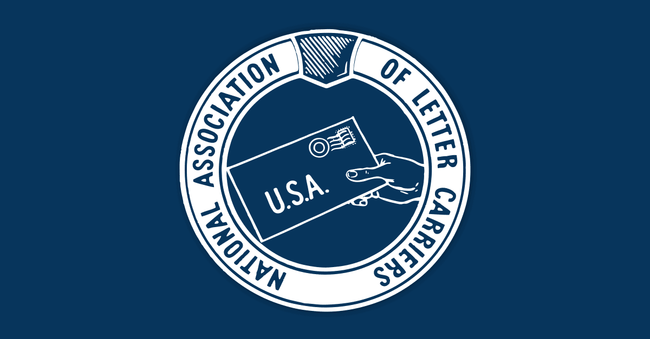  JUNE 2nd  Article 8 & Equitability Training  Setting stewards up for success  New in filing Article 8’s and Equitability? Interested in learning how to file and understand the grievance? Just want to know more about Article 8’s and Equitability? Join us on June 2nd for Article 8’s and Equitability training and learn how to handle the grievance to help teach and represent your fellow carriers!  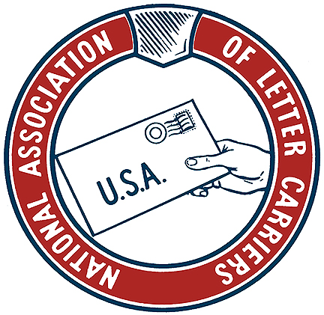 | What you need to know how to file Article 8’s  ────  How to file and know how to do Equitability.  ────  How to turn in RFI’s, review documents, and fill out spreadsheets  ────  How to build a winning case file  ────  What documents should be included in the grievance  Union Hall  6218 Krempen Ave  San Antonio, TX 78233  June 2nd @ 9 am

